Updating Jasper reports

1. The editing tool can be found here: <https://sourceforge.net/projects/jasperstudio/> . You can use it to edit the .jrxml files

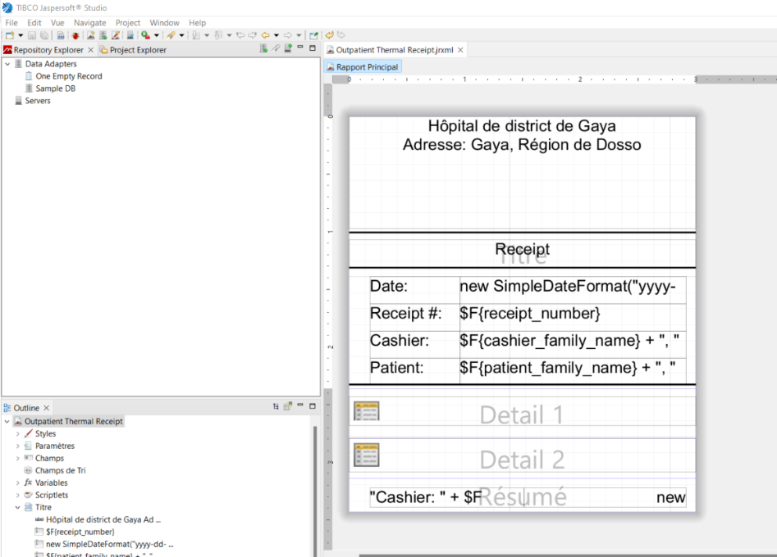

1. After editing select the .jrxml reports and compress them into a single .ZIP file.
2. On openmrs instance goto : <http://65.21.190.236:8080/openmrs/module/jasperreport/jreport.list>

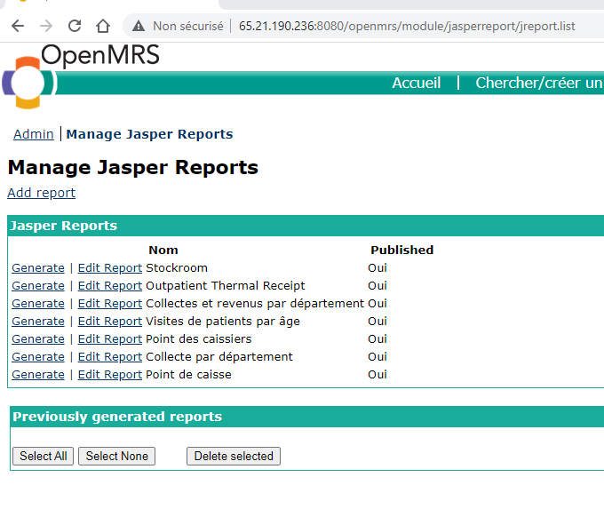

1. Click “Edit report”
2. On the report editing, enter the exact name of the .jrxml file to be used in “Top level report file name”, on “Report Archive” select the .ZIP file then click on “Save”

